ESP32 Smart Clock Programming Method

Version V1.0

Date 2023/05/15

By LG

**Preparing：**

1. ESP32 Smartclock Soldered
2. Micro USB 线
3. ESP32 flash Tool flash_download_tool at:  
   <https://www.espressif.com/en/support/download/other-tools>

**Steps：**

1. Connect ESP32 Smartclock soldered to PC with USB cable ; power the smartclock on, there should a new device with CP210X bridge port:

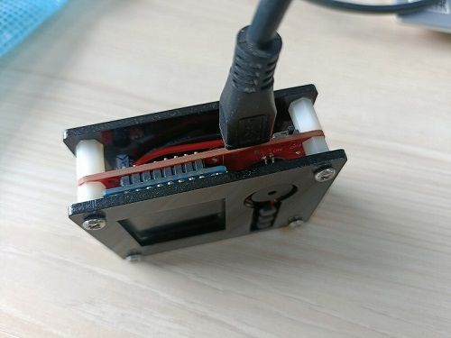

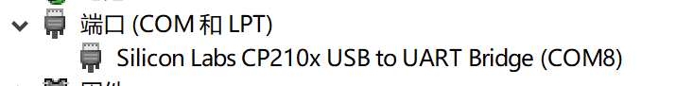

1. Open the ESP32 flash tool: flash_download_tool_v3.8.5

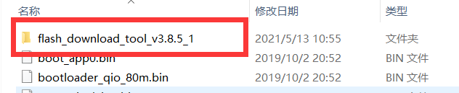

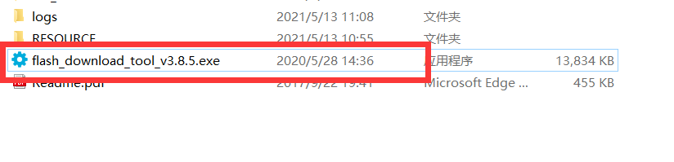

1. Select Developer Mode-------ESP32 DownloadTool

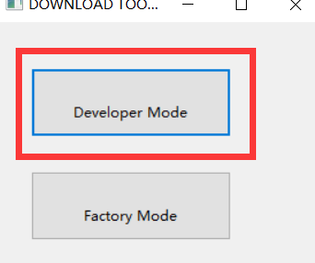 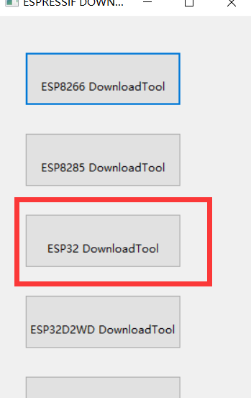

1. select the related bin files and the related programming address:

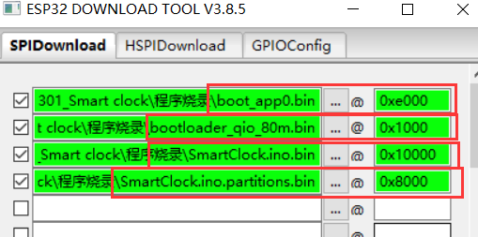

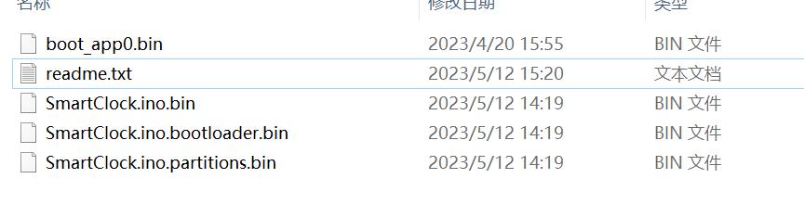

|  |  |
| --- | --- |
| 文件名 | 输入对应地址 |
| boot_app0.bin | 0xe000 |
| SmartClock.ino.bootloader.bin | 0x1000 |
| SmartClock.ino.bin | 0x10000 |
| SmartClock.ino.partitions.bin | 0x8000 |

1. setting the following specs:

